Creating microservices for account and loan

Eureka-server:

EurekaServerApplication.java
package com.cognizant.eureka_server;
import org.springframework.boot.SpringApplication;
import org.springframework.boot.autoconfigure.SpringBootApplication;
import org.springframework.cloud.netflix.eureka.server.EnableEurekaServer;
@SpringBootApplication
@EnableEurekaServer
public class EurekaServerApplication {
public static void main(String[] args) {
SpringApplication.run(EurekaServerApplication.class, args);
}
}
Application.properties
spring.application.name=eureka-discovery-server
server.port=8761
eureka.client.register-with-eureka=false
eureka.client.fetch-registry=false
logging.level.com.netflix.eureka=OFF
logging.level.com.netflix.discovery=OFF

pom.xml
<?xml version="1.0" encoding="UTF-8"?>
<project xmlns="http://maven.apache.org/POM/4.0.0" xmlns:xsi="http://www.w3.org/2001/XMLSchema-instance"
xsi:schemaLocation="http://maven.apache.org/POM/4.0.0 https://maven.apache.org/xsd/maven-4.0.0.xsd">
<modelVersion>4.0.0</modelVersion>
<parent>
<groupId>org.springframework.boot</groupId>
<artifactId>spring-boot-starter-parent</artifactId>
<version>3.5.3</version>
<relativePath/> <!-- lookup parent from repository -->
</parent>
<groupId>com.cognizant</groupId>
<artifactId>eureka-server</artifactId>
<version>0.0.1-SNAPSHOT</version>
<name>eureka-discovery-server</name>
<description>Demo project for Spring Boot</description>
<url/>
<licenses>
<license/>
</licenses>
<developers>
<developer/>
</developers>
<scm>
<connection/>
<developerConnection/>
<tag/>
<url/>
</scm>
<properties>
<java.version>21</java.version>
<spring-cloud.version>2025.0.0</spring-cloud.version>
</properties>
<dependencies>
<dependency>
<groupId>org.springframework.cloud</groupId>
<artifactId>spring-cloud-starter-netflix-eureka-server</artifactId>
</dependency>
<dependency>
<groupId>org.springframework.boot</groupId>
<artifactId>spring-boot-starter-test</artifactId>
<scope>test</scope>
</dependency>
</dependencies>
<dependencyManagement>
<dependencies>
<dependency>
<groupId>org.springframework.cloud</groupId>
<artifactId>spring-cloud-dependencies</artifactId>
<version>${spring-cloud.version}</version>
<type>pom</type>
<scope>import</scope>
</dependency>
</dependencies>
</dependencyManagement>
<build>
<plugins>
<plugin>
<groupId>org.springframework.boot</groupId>
<artifactId>spring-boot-maven-plugin</artifactId>
</plugin>
</plugins>
</build>
</project>
Output:
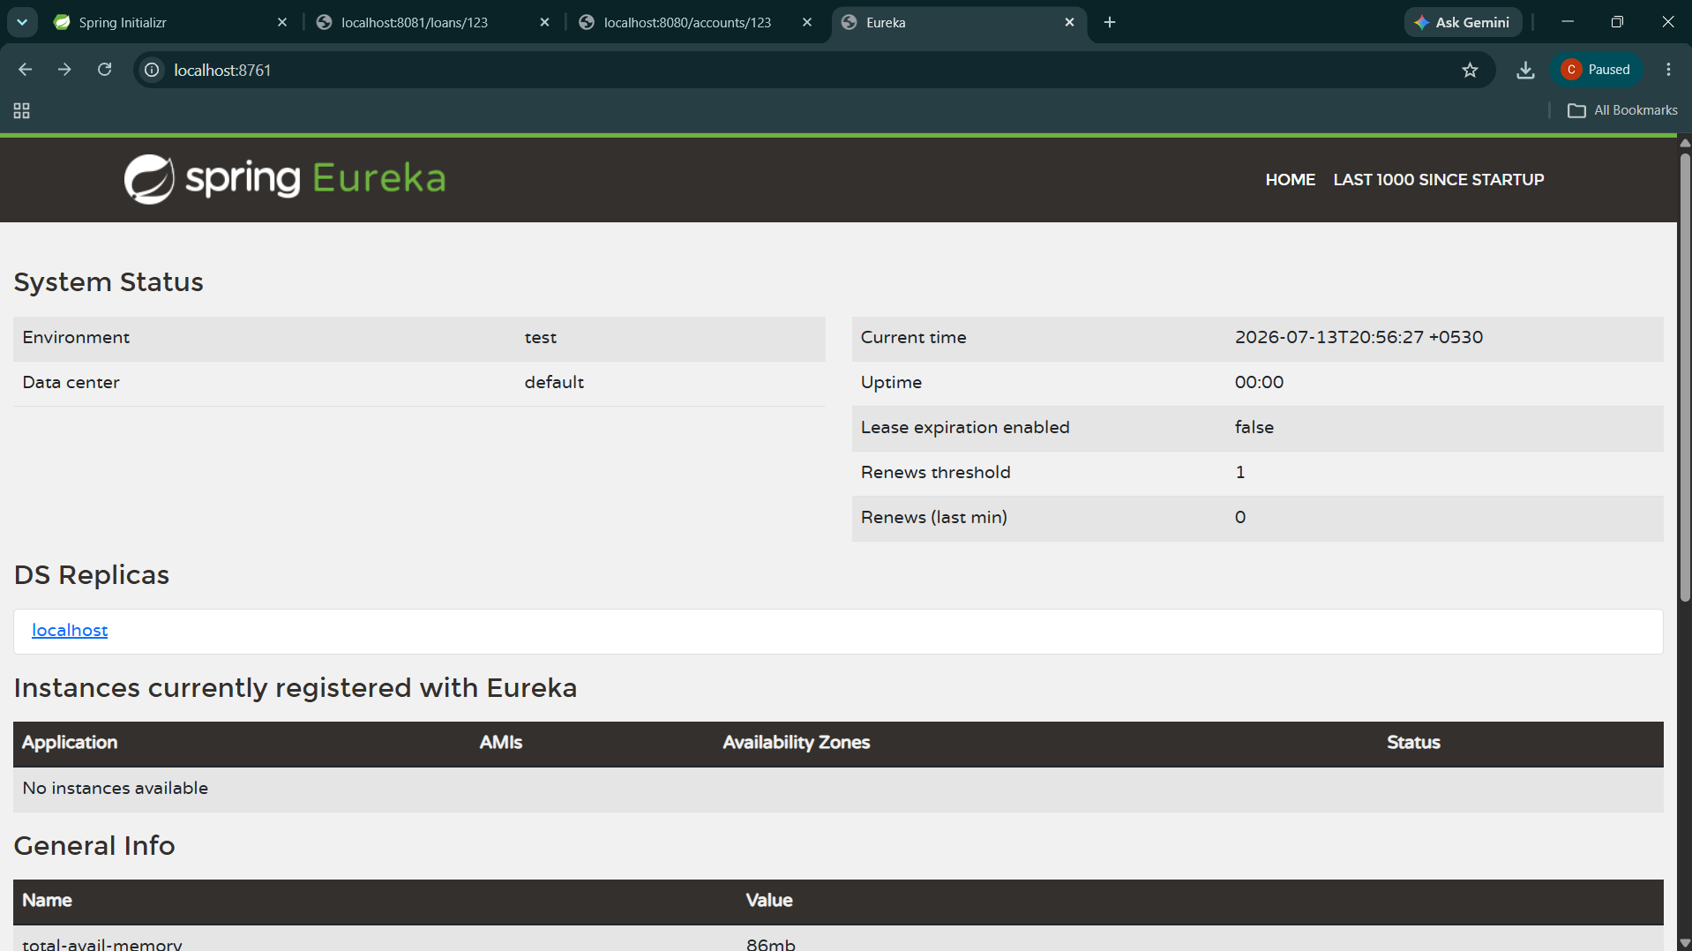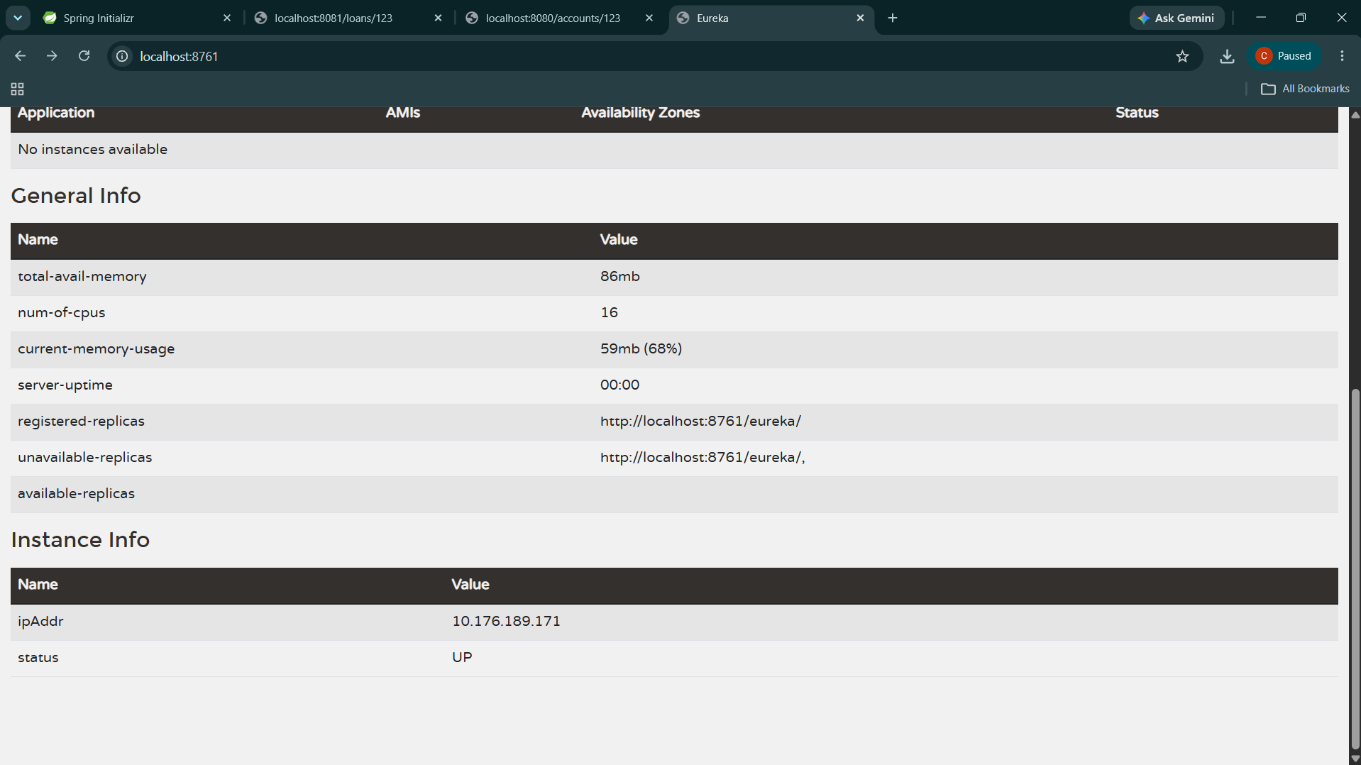

Loan:

LoanApplication.java
package com.cognizant.loan;
import org.springframework.boot.SpringApplication;
import org.springframework.boot.autoconfigure.SpringBootApplication;
import org.springframework.cloud.client.discovery.EnableDiscoveryClient;
@SpringBootApplication
@EnableDiscoveryClient
public class LoanApplication
{
public static void main(String[] args)
{
SpringApplication.run(LoanApplication.class, args);
}
}

LoanController.java
package com.cognizant.loan.controller;
import org.springframework.web.bind.annotation.GetMapping;
import org.springframework.web.bind.annotation.PathVariable;
import org.springframework.web.bind.annotation.RestController;
@RestController
public class LoanController
{

@GetMapping("/loans/{number}")
public String getLoanDetails(@PathVariable String number)
{
return "{ number: \"H00987987972342\", type: \"car\", loan: 400000, emi: 3258, tenure: 18 }";
}
}

Application.properties
eureka.client.service-url.defaultZone=http://localhost:8761/eureka/
spring.application.name=loan-service
server.port=8081
pom.xml
<?xml version="1.0" encoding="UTF-8"?>
<project xmlns="http://maven.apache.org/POM/4.0.0" xmlns:xsi="http://www.w3.org/2001/XMLSchema-instance"
xsi:schemaLocation="http://maven.apache.org/POM/4.0.0 https://maven.apache.org/xsd/maven-4.0.0.xsd">
<modelVersion>4.0.0</modelVersion>
<parent>
<groupId>org.springframework.boot</groupId>
<artifactId>spring-boot-starter-parent</artifactId>
<version>3.5.3</version>
<relativePath/> <!-- lookup parent from repository -->
</parent>
<groupId>com.cognizant</groupId>
<artifactId>loan</artifactId>
<version>0.0.1-SNAPSHOT</version>
<name>loan</name>
<description>Demo project for Spring Boot</description>
<url/>
<licenses>
<license/>
</licenses>
<developers>
<developer/>
</developers>
<scm>
<connection/>
<developerConnection/>
<tag/>
<url/>
</scm>
<properties>
<java.version>21</java.version>
</properties>
<dependencies>
<dependency>
<groupId>org.springframework.boot</groupId>
<artifactId>spring-boot-starter-web</artifactId>
</dependency>
<dependency>
<groupId>org.springframework.boot</groupId>
<artifactId>spring-boot-devtools</artifactId>
<scope>runtime</scope>
<optional>true</optional>
</dependency>
<dependency>
<groupId>org.springframework.boot</groupId>
<artifactId>spring-boot-starter-test</artifactId>
<scope>test</scope>
</dependency>
<dependency>
<groupId>org.springframework.cloud</groupId>
<artifactId>spring-cloud-starter-netflix-eureka-client</artifactId>
</dependency>
</dependencies>

<dependencyManagement>
<dependencies>
<dependency>
<groupId>org.springframework.cloud</groupId>
<artifactId>spring-cloud-dependencies</artifactId>
<version>2021.0.3</version>
<type>pom</type>
<scope>import</scope>
</dependency>
</dependencies>
</dependencyManagement>
<build>
<plugins>
<plugin>
<groupId>org.springframework.boot</groupId>
<artifactId>spring-boot-maven-plugin</artifactId>
</plugin>
</plugins>
</build>
</project>

Output:
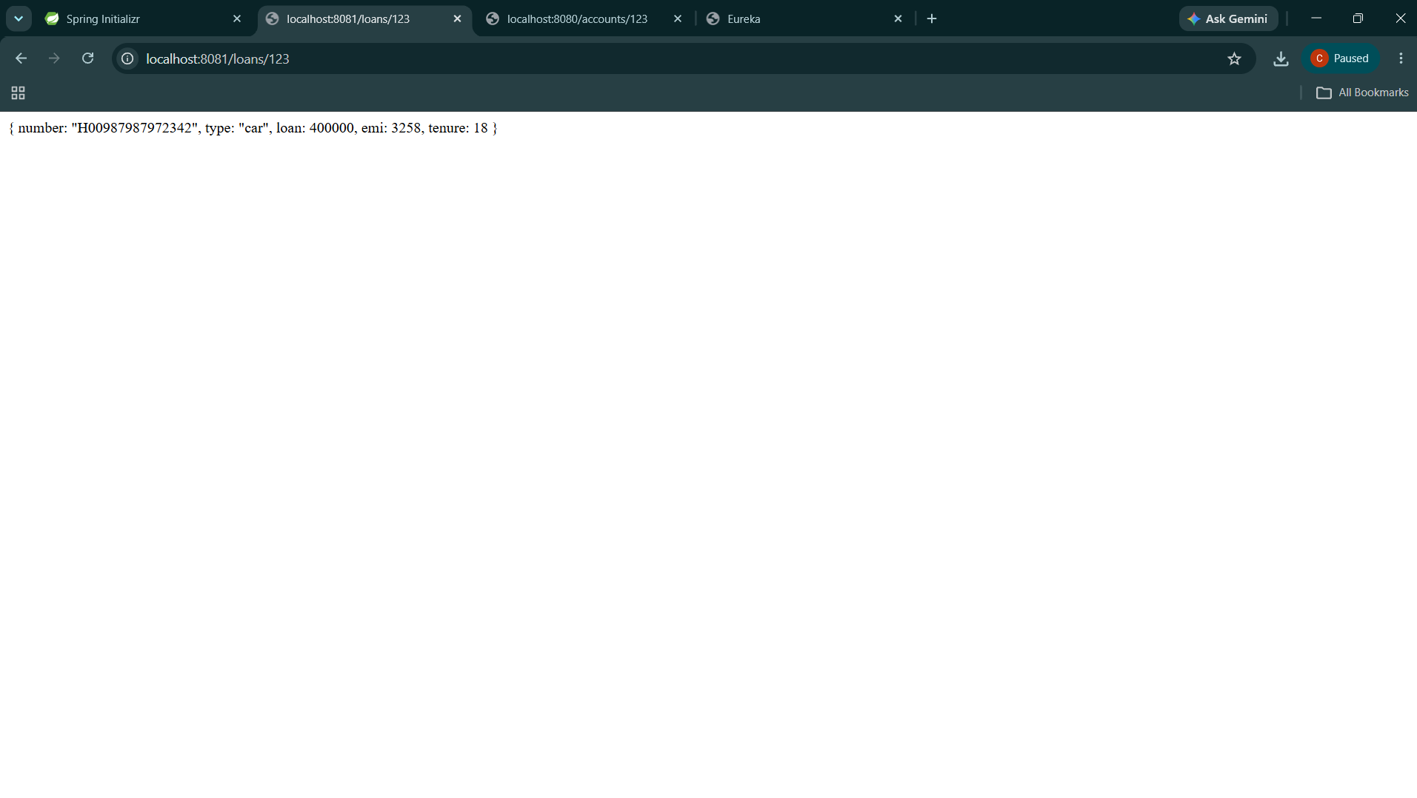

Account:
AccountApplication.java

package com.cognizant.account;
import org.springframework.boot.SpringApplication;
import org.springframework.boot.autoconfigure.SpringBootApplication;
import org.springframework.cloud.client.discovery.EnableDiscoveryClient;
@SpringBootApplication
@EnableDiscoveryClient
public class AccountApplication
{
public static void main(String[] args)
{
SpringApplication.run(AccountApplication.class, args);
}

}
AccountController.java
package com.cognizant.account.controller;
import org.springframework.web.bind.annotation.GetMapping;
import org.springframework.web.bind.annotation.PathVariable;
import org.springframework.web.bind.annotation.RestController;
@RestController
public class AccountController
{

@GetMapping("/accounts/{number}")
public String getAccountDetails(@PathVariable String number)
{
return "{ number: \"00987987973432\", type: \"savings\", balance: 234343 }";
}
}
Application.properties
eureka.client.service-url.defaultZone=http://localhost:8761/eureka/
spring.application.name=account-service

pom.xml
<?xml version="1.0" encoding="UTF-8"?>
<project xmlns="http://maven.apache.org/POM/4.0.0" xmlns:xsi="http://www.w3.org/2001/XMLSchema-instance"
xsi:schemaLocation="http://maven.apache.org/POM/4.0.0 https://maven.apache.org/xsd/maven-4.0.0.xsd">
<modelVersion>4.0.0</modelVersion>
<parent>
<groupId>org.springframework.boot</groupId>
<artifactId>spring-boot-starter-parent</artifactId>
<version>3.5.3</version>
<relativePath/> <!-- lookup parent from repository -->
</parent>
<groupId>com.cognizant</groupId>
<artifactId>account</artifactId>
<version>0.0.1-SNAPSHOT</version>
<name>account</name>
<description>Demo project for Spring Boot</description>
<url/>
<licenses>
<license/>
</licenses>
<developers>
<developer/>
</developers>
<scm>
<connection/>
<developerConnection/>
<tag/>
<url/>
</scm>
<properties>
<java.version>21</java.version>
</properties>
<dependencies>
<dependency>
<groupId>org.springframework.boot</groupId>
<artifactId>spring-boot-starter-web</artifactId>
</dependency>
<dependency>
<groupId>org.springframework.boot</groupId>
<artifactId>spring-boot-devtools</artifactId>
<scope>runtime</scope>
<optional>true</optional>
</dependency>
<dependency>
<groupId>org.springframework.boot</groupId>
<artifactId>spring-boot-starter-test</artifactId>
<scope>test</scope>
</dependency>
<dependency>
<groupId>org.springframework.cloud</groupId>
<artifactId>spring-cloud-starter-netflix-eureka-client</artifactId>
</dependency>
</dependencies>

<dependencyManagement>
<dependencies>
<dependency>
<groupId>org.springframework.cloud</groupId>
<artifactId>spring-cloud-dependencies</artifactId>
<version>2021.0.3</version>
<type>pom</type>
<scope>import</scope>
</dependency>
</dependencies>
</dependencyManagement>
<build>
<plugins>
<plugin>
<groupId>org.springframework.boot</groupId>
<artifactId>spring-boot-maven-plugin</artifactId>
</plugin>
</plugins>
</build>
</project>

Output:
